NC Division of Parks and Recreation

July 1, 2015

STAFF DIRECTIVE 15-02

TO: Administrative Staff
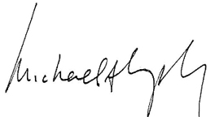
Section Chiefs
District Superintendents
Park Superintendents

FROM: Michael A. Murphy, Director

SUBJECT: Critical Incident Stress Management (CISM) Policy - July 2015 Revision

This Staff Directive is a revision to Staff Directives 2002-06, 2003-03 and the 2003 Critical Incident Stress Management (CISM) Policy and is effective immediately.

Unfortunately, traumatic events involving the public and/or fellow Division employees will occur at some time during a person’s career. These traumatic experiences will often create physical and emotional stress for employees that may become involved in these events. Having a system for debriefing, peer support and professional counseling in a confidential setting will often help to alleviate these emotional burdens from the involved employee(s). In an effort to assist Division employees involved in such critical or traumatic events, this Critical Incident Stress Management Policy was established and through periodic reviews will continue to be an important resource for employee well-being.

MAM/bad

